TMRC ISLAMABAD
MOSQUITO (DENGUE OR NON DENGUE)
INTERNSHIP TASK 7:

PROJECT REPORT
STUDENT NAME: M.Talha Wali Khan
INTERNSHIP: TMR CONSULING ISLAMABAD
DATE: 01 OCT 2026.
This project uses deep learning and a web application to classify uploaded images into three categories: Not Mosquito, Dengue-Vector Species, and Non-Dengue Mosquito.
1.Objectives
1.Build an AI model to recognize mosquito images.
2.Distinguish dengue-vector species from other mosquito species.
3. Reject images that are not mosquitoes.
4. Integrate the trained model with a simple web app for image upload and prediction.
2. Dataset:
The project uses mosquito images organized into dengue-vector and other-mosquito folders, along with non-mosquito images from CIFAR-10 and CIFAR-100.
The training setup aims to use up to 3,000 images per class for a balanced dataset.
3. Model and Training:
The project uses MobileNetV2 with ImageNet pretrained weights as the image feature extractor. The model resizes images to 128 × 128 pixels, applies augmentation during training, and predicts one of three classes using a softmax output. Training is configured for up to 5 epochs with a training/validation split and callbacks to save the best checkpoint and stop early when appropriate.
4. Web Application:
The Flask application allows a user to upload an image and displays the model's predicted category and confidence. A confidence threshold can show an uncertain result when the model's confidence is below the configured limit.
5.Limitations and Conclusion.
The system classifies image categories; it does not determine whether an individual mosquito is infected with dengue virus. A species label is not proof of infection, and a three-class model may still misclassify unfamiliar objects. Results should be treated as an AI demonstration, not a medical or diagnostic tool. The project demonstrates an end-to-end workflow from image data and model training to web-based prediction.
OUTPUT:
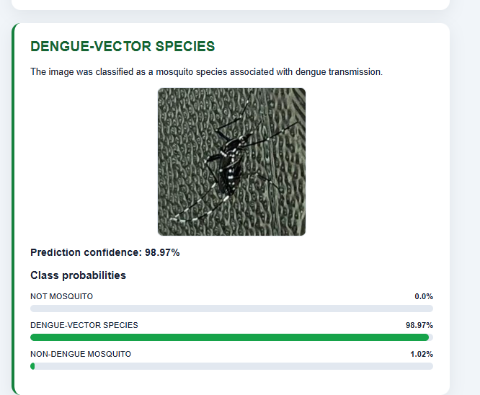

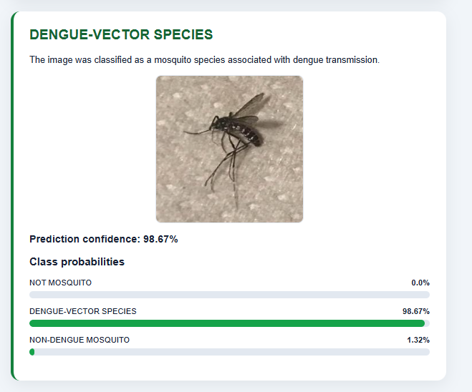

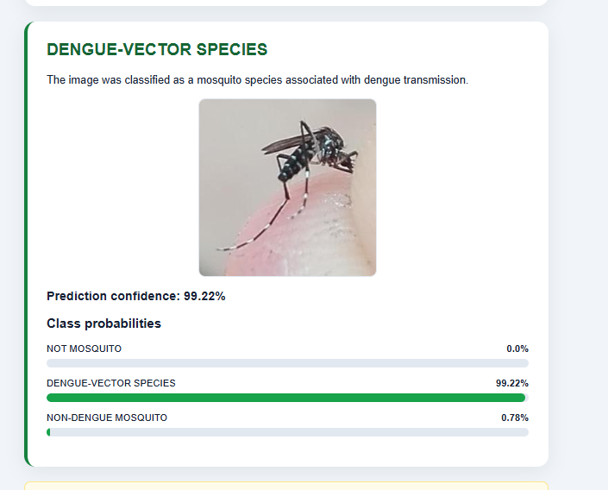

NON DENGUE:
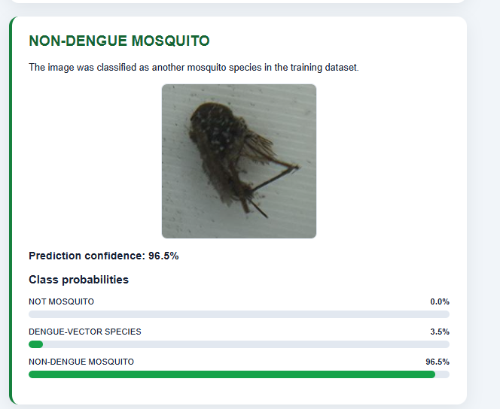

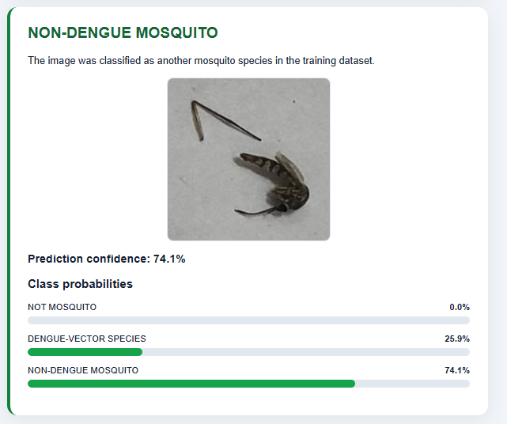

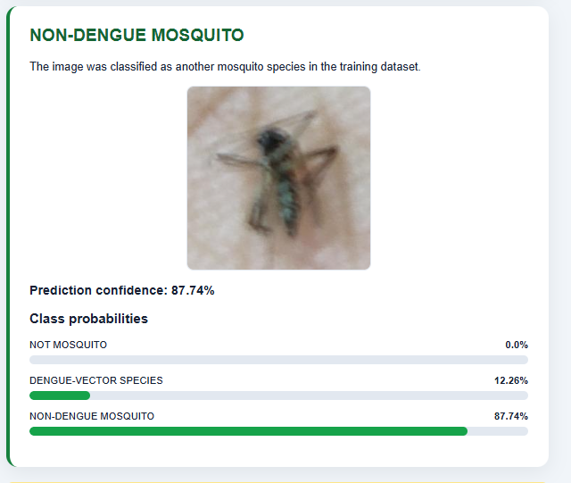

OTHER MOSQUITO:
